Name | Soham Joshi
Roll no | 24204C0021
Batch | 1
Subject name | Python Programming & Data Structure
Teacher Name | Ms. Rasika Patil

Experiments | 15
Title | *Develop python program to implement operations (Create, Insert, Delete, Traverse) on Singly Linked List.

Programming Questions with Answer
1 | Program to create and traverse a Singly Linked List
SCRIPT | 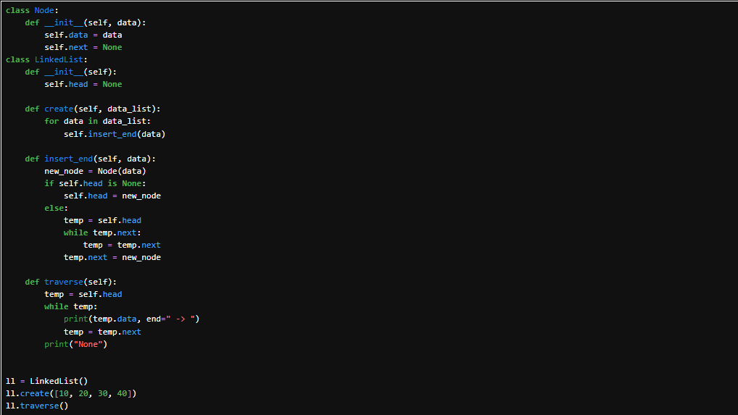
OP
2 | Program to insert a new node at the beginning
SCRIPT | 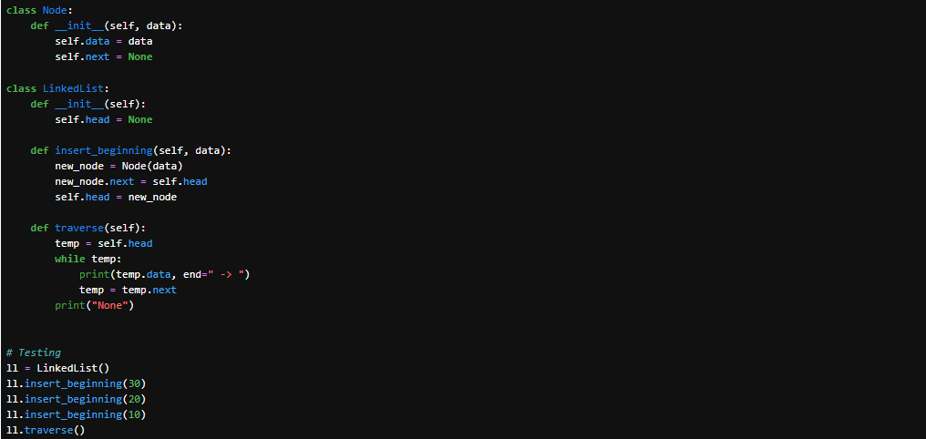
OP | 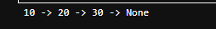
3 | Program to delete a node
SCRIPT | 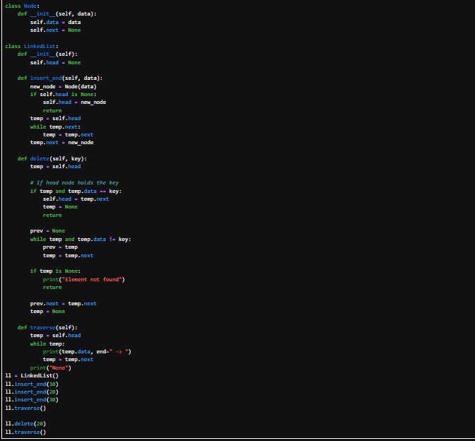
OP | 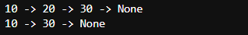
Debugging Questions with Corrected Answers
1 | Debug the following code  Wrong code:  class Node:  def __init__(data):  self.data = data
OP | Error: TypeError: __init__() takes 1 positional argument but 2 were given  Correct code: class Node:  def __init__(self, data):  self.data = data  self.next = None
2 | Debug the following code  Wrong code:  if temp.data = key:  head = temp.next
OP | Error: SyntaxError: invalid syntax  Correct code: if temp.data == key:  head = temp.next
Conclusion | In this experiment, we successfully implemented a Singly Linked List in Python and performed essential operations such as create, insert, delete, and traverse. The implementation helped us understand how dynamic memory allocation works in linked data structures, where each node contains data and a reference to the next node. We also learned how insertion and deletion operations are efficiently handled without shifting elements, unlike arrays. Additionally, debugging common errors improved our understanding of constructors and comparison operators in Python. Overall, this experiment enhanced our knowledge of linear data structures and their practical implementation in real-world applications.
Performance Indicators |  | Teachers Dated and Signature
Process Related  (15 M) | Product Related  (10 M) | Total (25 M)

